Learner: Date:
Aims and objectives
At the end of this activity sheet, you should be able to:
- Describe the need to use the appropriate PPE at all times

Task 1
Complete the table. Be specific eg ‘injuries from..’

PPE | Protects against | Possible consequences of not wearing it
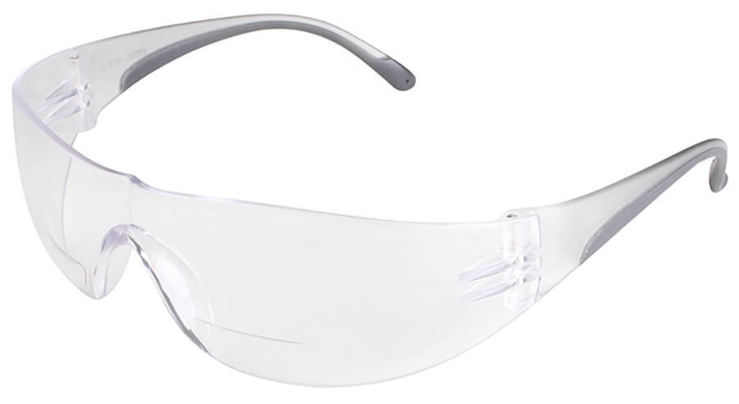

Name:
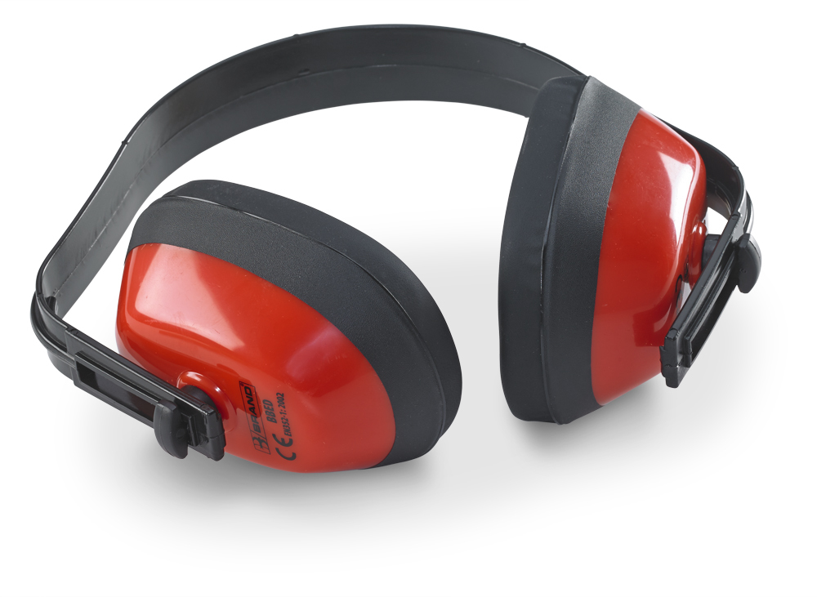
Name:
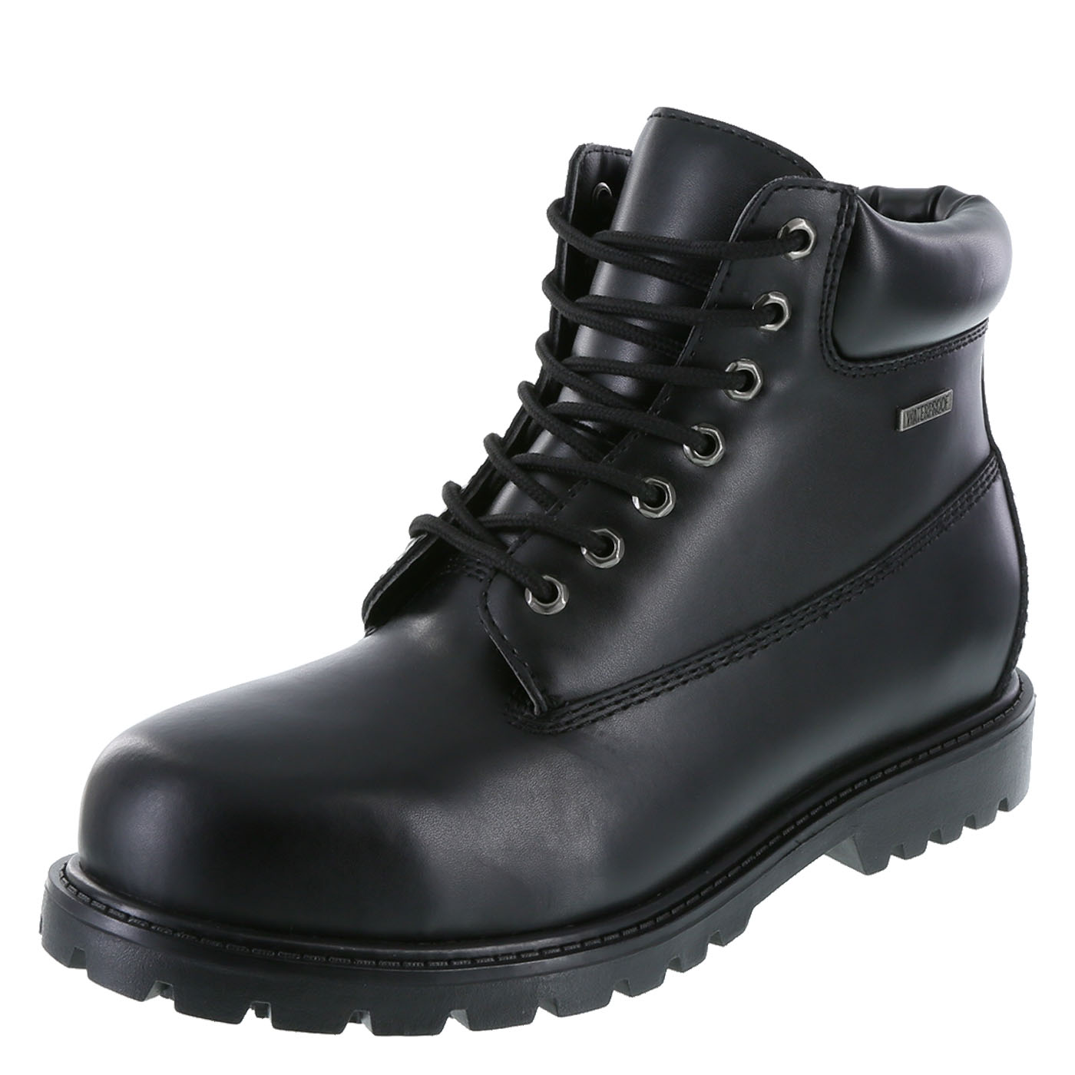

Name:

PPE | Protects against | Possible consequences of not wearing it
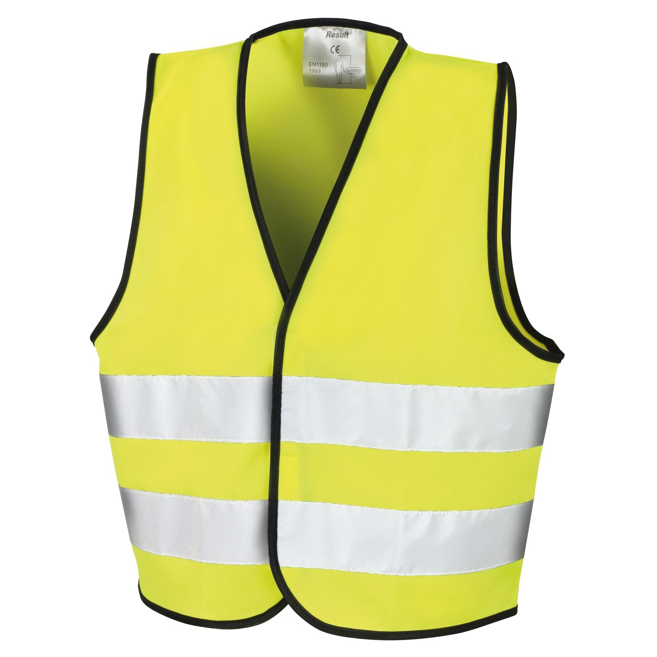

Name:


Name:
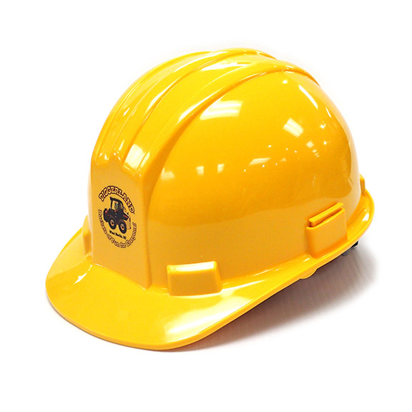
Name:
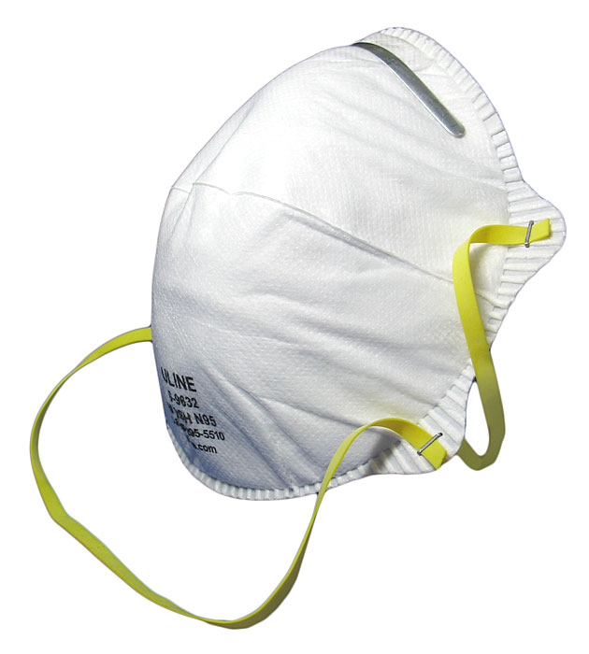

Name:

